

**GRAVEYARD MANAGEMENT SYSTEM**

**GROUP MEMBERS**

MIRA, ZARIN IFFAT 17-35447-3

MALAKAR, SATYAJIT 18-36797-1

SHOME, PRAJNA SHIRSO 18-36805-1

RIAD, AHSUN MAHMUD RIAD 18-36814-1

**COURSE NAME: INTRODUCTION TO DATABASE**

**FACULTY NAME: JUENA AHMED NOSHIN**

**SECTION: E1 & E2**

**CONTEN LISTS:**

1. Introduction.
2. Scenario.
3. E-R Diagram.
4. Normalization.
5. Table Creation.
6. Data Insertion.
7. Query Writing.
8. Conclusion.

**Introduction:**

A database management system (DBMS) is system software for creating and managing databases. The DBMS provides users and programmers with a systematic way to create, retrieve, update and manage data. DBMS makes it possible for end users to create, read, update and delete data in a database. The DBMS essentially serves as an interface between the database and end users or application programs, ensuring that data is consistently organized and remains easily accessible.

Our ‘Graveyard Management System’ project is built on the concept of database management system. Our main purpose of the project was to analyze and implement the basic concept of DBMS.

**Scenario:**

In our graveyard management system, the city corporation owns the graveyard. The city corporation is identified by id, name, e_mail, phone_number & address. They controls zone officers who are in charge of the graveyard. Zone officer is identified by o_id, o_name, o_address, o_phone_number, o_e_mail, NID & gender. The zone officer recruits exactly one manager for managing the graveyard. The graveyard is identified by the grvyrd_id, grvyrd_name, grvyrd_area & grvyrd_address. The manager is identified by the m_id, m_name, address, NID, phone_number, e_mail, date_of_birth, hiredate, salary, blood_group & gender. The graveyard provides grave for the corps. The grave may known by grave_id, location & type. The location has two attributes: block & plot. Type has three attributes: adult, young and child. When the manager received a corps from the relative, s/he inputs corps information into system as c_id, c_name, NID, address, gender, date_of_birth, date_of _death & death_certificate_no. After that, the system automatically decides the grave for burying the corps. The relative pays the fees to the manager. Relative may identified by r_name, r_address and r_phone_number. For doing all of this, the manager recruit employees, who are categorized into department. Department can be defined by dept_id & dept_name. The employees are identified by emp_no, emp_name, address, phone_number, e_mail, date_of_birth, hiredate, salary, boold_group & gender. The manager also recruit imam for the ritual process. He is identified by i_id, i_name, address, phone_number, date_of_birth, hiredate, salary, boold_group. The employees helps the imam doing the ritual process.

**NORMALIZATION**

**Employee------*------Categorize------1------Department**

UNF:

Categorize

Emp_No, Emp_Name, NID, Address, E_mail, Phone_Number, Hiredate, Blood_Group, Date_of_Birth, Salary, Gender, Dept_ID, Dept_Name.

1NF:

Phone_Number & E_mail are multivalued attribute.

Emp_No, Emp_Name, NID, Address, E_mail, Phone_Number, Hiredate, Blood_Group, Date_of_Birth, Salary, Gender, Dept_ID, Dept_Name.

2NF:

1. Emp_No, Emp_Name, NID, Address, E_mail, Phone_Number, Hiredate, Blood_Group, Date_of_Birth, Gender, Salary.
2. Dept_Name, Dept_ID.

3NF:

No transitive dependency.

1. Emp_No, Emp_Name, NID, Address, E_mail, Phone_Number, Hiredate, Blood_Group, Date_of_Birth, Gender, Salary.
2. Dept_Name, Dept_ID.

Table:

1. Emp_No, Emp_Name, NID, Address, E_mail, Phone_Number, Hiredate, Blood_Group, Date_of_Birth, Salary, Gender, **Dept_ID**.
2. Dept_Name, Dept_ID.

**Manager------1------Recruit------*------Employee**

UNF:

Recruit

Emp_No, Emp_Name, NID, Address, E_mail, Phone_Number, Hiredate, Blood_Group, Date_of_Birth, Salary, M_ID, M_Name, Address, Hiredate, Date_of_Birth, NID, Gender, Blood_Group, Salary, E_mail, Gender, Phone_Number.

1NF:

Phone_Number & E_mail are multivalued attribute.

Emp_No, Emp_Name, NID, Address, E_mail, Phone_Number, Hiredate, Blood_Group, Date_of_Birth, Gender, Salary, M_ID, M_Name, NID, Address, E_mail, Phone_Number, Gender, Blood_Group, Date_of_Birth, Hiredate, Salary.

2NF:

1. Emp_No, Emp_Name, NID, Address, E_mail, Phone_Number, Hiredate, Blood_Group, Date_of_Birth, Gender, Salary.
2. M_ID, M_Name, NID, Address, E_mail, Phone_Number, Gender, Blood_Group, Date_of_Birth, Hiredate, Salary.

3NF:

No transitive dependency.

1. Emp_No, Emp_Name, NID, Address, E_mail, Phone_Number, Hiredate, Blood_Group, Date_of_Birth, Gender, Salary.
2. M_ID, M_Name, NID, Address, E_mail, Phone_Number, Gender, Blood_Group, Date_of_Birth, Hiredate, Salary.

Table:

1. Emp_No, Emp_Name, NID, Address, E_mail, Phone_Number, Hiredate, Blood_Group, Date_of_Birth, Salary, Gender, **M_ID**.
2. M_ID, M_Name, NID, Address, E_mail, Phone_Number, Gender, Blood_Group, Date_of_Birth, Hiredate, Salary.

**Manager------1------Manage------1------Graveyard**

UNF:

Manage

GrvYrDept_ID, GrvYrDept_Name, GrvYrd_Area, GrvYrd_Address, M_ID, M_Name, NID, Address, E_mail, Phone_Number, Gender, Blood_Group, Date_of_Birth, Hiredate, Salary.

1NF:

Phone_Number & E_mail are multivalued attribute.

GrvYrDept_ID, GrvYrDept_Name, GrvYrd_Area, GrvYrd_Address, M_ID, M_Name, NID, Address, E_mail, Phone_Number, Gender, Blood_Group, Date_of_Birth, Hiredate, Salary.

2NF:

1. GrvYrDept_ID, GrvYrDept_Name, GrvYrd_Area, GrvYrd_Address.
2. M_ID, M_Name, NID, Address, E_mail, Phone_Number, Gender, Blood_Group, Date_of_Birth, Hiredate, Salary.

3NF:

No transitive dependency.

1. GrvYrDept_ID, GrvYrDept_Name, GrvYrd_Area, GrvYrd_Address.
2. M_ID, M_Name, NID, Address, E_mail, Phone_Number, Gender, Blood_Group, Date_of_Birth, Hiredate, Salary.

Table:

1. GrvYrDept_ID, GrvYrDept_Name, GrvYrd_Area, GrvYrd_Address.
2. M_ID, M_Name, NID, Address, E_mail, Phone_Number, Gender, Blood_Group, Date_of_Birth, Hiredate, Salary, **GrvYrDept_ID**.

**Zone Officer------*------Recruit------1------Manager**

UNF:

Recruit

O_ID, O_Name, O_Address, O_Phone Number, O_ E_mail, NID, Gender, M_ID, M_Name, NID, Address, E_mail, Phone_Number, Gender, Blood_Group, Date_of_Birth, Hiredate, Salary.

1NF:

Phone_Number & E_mail are multivalued attribute.

O_ID, O_Name, O_Address, O_Phone Number, O_ E_mail, NID, Gender, M_ID, M_Name, NID, Address, E_mail, Phone_Number, Gender, Blood_Group, Date_of_Birth, Hiredate, Salary.

2NF:

1. O_ID, O_Name, O_Address, O_Phone Number, O_ E_mail, NID, Gender.
2. M_ID, M_Name, NID, Address, E_mail, Phone_Number, Gender, Blood_Group, Date_of_Birth, Hiredate, Salary.

3NF:

No transitive dependency.

1. O_ID, O_Name, O_Address, O_Phone Number, O_ E_mail, NID, Gender.
2. M_ID, M_Name, NID, Address, E_mail, Phone_Number, Gender, Blood_Group, Date_of_Birth, Hiredate, Salary.

Table:

1. O_ID, O_Name, O_Address, O_Phone Number, O_ E_mail, NID, Gender, **M_ID**.
2. M_ID, M_Name, NID, Address, E_mail, Phone_Number, Gender, Blood_Group, Date_of_Birth, Hiredate, Salary.

**City Corporation------1------Own------*------Graveyard**

UNF:

Own

ID, Name, E_mail, Phone Number, Address, GrvYrDept_ID, GrvYrDept_Name, GrvYrd_Area, GrvYrd_Address.

1NF:

Phone_Number & E_mail are multivalued attribute.

ID, Name, E_mail, Phone Number, Address, GrvYrDept_ID, GrvYrDept_Name, GrvYrd_Area, GrvYrd_Address.

2NF:

1. ID, Name, E_mail, Phone Number, Address.
2. GrvYrDept_ID, GrvYrDept_Name, GrvYrd_Area, GrvYrd_Address.

3NF:

No transitive dependency.

1. ID, Name, E_mail, Phone Number, Address.
2. GrvYrDept_ID, GrvYrDept_Name, GrvYrd_Area, GrvYrd_Address.

Table:

1. ID, Name, E_mail, Phone Number, Address.
2. GrvYrDept_ID, GrvYrDept_Name, GrvYrd_Area, GrvYrd_Address, **ID**.

**Graveyard------1------Provide------*------Grave**

UNF:

Provide

Grave_ID, Block, Plot, Adult, Young, Child, GrvYrd_ID, GrvYrd_Name, GrvYrd_Area, GrvYrd_Address.

1NF:

No multivalued attribute.

Grave_ID, Block, Plot, Adult, Young, Child, GrvYrd_ID, GrvYrd_Name, GrvYrd_Area, GrvYrd_Address.

2NF:

1. Grave_ID, Block, Plot, Adult, Young, Child.
2. GrvYrDept_ID, GrvYrDept_Name, GrvYrd_Area, GrvYrd_Address.

3NF:

1. Grave_ID.
2. Block, Plot.
3. Adult, Young, Child
4. GrvYrDept_ID, GrvYrDept_Name, GrvYrd_Area, GrvYrd_Address.

**Table:**

1. Grave_ID, **Loc_ID**, **Grave_Size_ID**, **GrvYrDept_ID**.
2. Loc_ID, Block, Plot.
3. Grave_Size _ID, Adult, Young, Child.
4. GrvYrDept_ID, GrvYrDept_Name, GrvYrd_Area, GrvYrd_Address.

**City Corporation------1------Control------*------Zone Officer**

UNF:

Control

ID, Name, E_mail, Phone Number, Address, O_ID, O_Name, O_Address, O_Phone Number, O_ E_mail, NID, Gender.

1NF:

E_mail, Phone Number, O_Address, O_Phone Number are multivalued attribute.

ID, Name, E_mail, Phone Number, Address, O_ID, O_Name, O_Address, O_Phone Number, O_ E_mail, NID, Gender.

2NF:

1. ID, Name, E_mail, Phone Number, Address.
2. O_ID, O_Name, O_Address, O_Phone Number, O_ E_mail, NID, Gender.

3NF:

No transitive dependency.

1. ID, Name, E_mail, Phone Number, Address.
2. O_ID, O_Name, O_Address, O_Phone Number, O_ E_mail, NID, Gender.

Table:

1. ID, Name, E_mail, Phone Number, Address.
2. O_ID, O_Name, O_Address, O_Phone Number, O_ E_mail, NID, Gender, **ID**.

**Grave------1------Burry------1------Corpse**

UNF:

Burry

Grave_ID, Block, Plot, Adult, Young, Child, C_ID, C_Name, NID, Death_Certificate_No, C_Address, Date_of_Birth, Date_of_Death, Reason_of_Death, Gender.

1NF:

No multivalued attribute.

Grave_ID, Block, Plot, Adult, Young, Child, C_ID, C_Name, NID, Death_Certificate_No, C_Address, Date_of_Birth, Date_of_Death, Reason_of_Death, Gender.

2NF:

1. Grave_ID, Block, Plot, Adult, Young, Child.
2. C_ID, C_Name, NID, Death_Certificate_No, C_Address, Date_of_Birth, Date_of_Death, Reason_of_Death, Gender.

3NF:

1. Grave_ID.
2. Block, Plot.
3. Adult, Young, Child.
4. C_ID, C_Name, NID, Death_Certificate_No, C_Address, Date_of_Birth, Date_of_Death, Reason_of_Death, Gender.

Table:

1. Grave_ID, **Loc_ID**, **Grave_Size**, **C_ID**.
2. Loc_ID, Block, Plot.
3. Grave_Size _ID, Adult, Young, Child.
4. C_ID, C_Name, NID, Death_Certificate_No, C_Address, Date_of_Birth, Date_of_Death, Reason_of_Death, Gender.

**Manager------1------Receive------*------Corpse**

UNF:

Receive

M_ID, M_Name, Address, Phone Number, E_mail, Salary, Blood Group, Gender, NID, Date_of_Birth, Hiredate, C_ID, C_Name, NID, Death_Certificate_No, C_Address, Date_of_Birth, Date_of_Death, Reason_of_Death, Gender.

1NF:

Phone Number & E_mail are multivalued attribute.

M_ID, M_Name, Address, Phone Number, E_mail, Salary, Blood_Group, Gender, NID, Date_of_Birth, Hiredate, C_ID, C_Name, NID, Death_Certificate_No, C_Address, Date_of_Birth, Date_of_Death, Reason_of_Death, Gender.

2NF:

1. M_ID, M_Name, Address, Phone Number, E_mail, Salary, Blood_Group, Gender, NID, Date_of_Birth, Hiredate.
2. C_ID, C_Name, NID, Death_Certificate_No, C_Address, Date_of_Birth, Date_of_Death, Reason_of_Death, Gender.

3NF:

No transitive dependency.

1. M_ID, M_Name, Address, Phone Number, E_mail, Salary, Blood Group, Gender, NID, Date_of_Birth, Hiredate.
2. C_ID, C_Name, NID, Death_Certificate_No, C_Address, Date_of_Birth, Date_of_Death, Reason_of_Death, Gender.

Table:

1. M_ID, M_Name, Address, Phone Number, E_mail, Salary, Blood_Group, Gender, NID, Date_of_Birth, Hiredate.
2. C_ID, C_Name, NID, Death_Certificate_No, C_Address, Date_of_Birth, Date_of_Death, Reason_of_Death, Gender, **M_ID**.

**Relative------*------Pays------1------Manager**

UNF:

Pays

M_ID, M_Name, Address, Phone Number, E_mail, Salary, Blood_Group, Gender, NID, Date_of_Birth, Hiredate, R_Name, R_Address, R_Phone_No.

1NF:

Phone Number & E_mail are multivalued attribute.

M_ID, M_Name, Address, Phone Number, E_mail, Salary, Blood_Group, Gender, NID, Date_of_Birth, Hiredate, R_Name, R_Address, R_Phone_No.

2NF:

1. M_ID, M_Name, Address, Phone Number, E_mail, Salary, Blood_Group, Gender, NID, Date_of_Birth, Hiredate.
2. R_Name, R_Address, R_Phone_No.

3NF:

No transitive dependency.

1. M_ID, M_Name, Address, Phone Number, E_mail, Salary, Blood Group, Gender, NID, Date_of_Birth, Hiredate.
2. R_Name, R_Address, R_Phone_No.

Table

1. M_ID, M_Name, Address, Phone Number, E_mail, Salary, Blood Group, Gender, NID, Date_of_Birth, Hiredate.
2. R_Name, R_Address, R_Phone_No, **M_ID**.
3. **M_ID** , R_Name.

**Relative------*------Has------1------Corpse**

UNF:

Has

C_ID, C_Name, NID, Death_Certificate_No, C_Address, Date_of_Birth, Date_of_Death, Reason_of_Death, Gender, R_Name, R_Address, R_Phone_No, R_Name, R_Address, R_Phone_No.

1NF:

R_Phone_No is a multivalued attribute.

C_ID, C_Name, NID, Death_Certificate_No, C_Address, Date_of_Birth, Date_of_Death, Reason_of_Death, Gender, R_Name, R_Address, R_Phone_No, R_Name, R_Address, R_Phone_No.

2NF:

1. C_ID, C_Name, NID, Death_Certificate_No, C_Address, Date_of_Birth, Date_of_Death, Reason_of_Death, Gender, R_Name, R_Address.
2. R_Name, R_Address, R_Phone_No, R_Name, R_Address, R_Phone_No.

3NF:

No transitive dependency.

1. C_ID, C_Name, NID, Death_Certificate_No, C_Address, Date_of_Birth, Date_of_Death, Reason_of_Death, Gender, R_Name, R_Address.
2. R_Name, R_Address, R_Phone_No, R_Name, R_Address, R_Phone_No.

Table:

1. C_ID, C_Name, NID, Death_Certificate_No, C_Address, Date_of_Birth, Date_of_Death, Reason_of_Death, Gender, R_Name, R_Address.
2. R_Name, R_Address, R_Phone_No, R_Name, R_Address, R_Phone_No, **C_ID**.
3. **C_ID**, R_Name.

**Table Creation**

1. ID, Name, E_mail, Phone Number, Address.
2. GrvYrd_ID, GrvYrd_Name, GrvYrd_Area, GrvYrd_Address, **ID**.
3. M_ID, M_Name, NID, Address, E_mail, Phone_Number, Gender, Blood_Group, Date_of_Birth, Hiredate, Salary, **GrvYrDept_ID**.
4. Emp_No, Emp_Name, NID Address, E_mail, Phone_Number, Hiredate, Blood_Group, Date_of_Birth, Gender, Salary, **Dept_ID**, **M_ID**.
5. Dept_ID, Dept_Name.
6. O_ID, O_Name, O_Address, O_Phone Number, O_ E_mail, NID, Gender, **M_ID**, **ID**.
7. C_ID, C_Name, NID, Death_Certificate_No, C_Address, Date_of_Birth, Date_of_Death, Reason_of_Death, Gender, **M_ID**.
8. R_Name, R_Address, R_Phone_No, **M_ID**, **C_ID**.
9. **M_ID** , **C_ID,** R_Name.
10. Grave_ID, **Loc_ID**, **Grave_Size_ID**, **GrvYrd_ID**, **C_ID**.
11. Loc_ID, Block, Plot.
12. Grave_Size_ID, Adult, Young, Child.
13. ~~Emp_No, Emp_Name, Address, E_mail, Phone_Number, Hiredate, Blood_Group, Date_of_Birth, Salary,~~ **~~M_ID~~**~~.~~
14. ~~M_ID, M_Name, NID, Address, E_mail, Phone_Number, Gender, Blood_Group, Date_of_Birth, Hiredate, Salary.~~
15. ~~GrvYrd_ID, GrvYrd_Name, GrvYrd_Area, GrvYrd_Address.~~
16. ~~M_ID, M_Name, NID, Address, E_mail, Phone_Number, Gender, Blood_Group, Date_of_Birth, Hiredate, Salary.~~
17. ~~GrvYrd_ID, GrvYrd_Name, GrvYrd_Area, GrvYrd_Address.~~
18. ~~ID, Name, E_mail, Phone Number, Address.~~
19. ~~O_ID, O_Name, O_Address, O_Phone Number, O_ E_mail, NID, Gender,~~ **~~ID~~**~~.~~
20. ~~Grave_ID,~~ **~~Loc_ID~~**~~,~~ **~~Grave_Size~~**~~,~~ **~~C_ID~~**~~.~~
21. ~~Loc_ID, Block, Plot.~~
22. ~~Grave_Size _ID, Adult, Young, Child.~~
23. ~~C_ID, C_Name, NID, Death_Certificate_No, C_Address, Date_of_Birth, Date_of_Death, Reason_of_Death, Gender.~~
24. ~~M_ID, M_Name, Address, Phone Number, E_mail, Salary, Blood_Group, Gender, NID, Date_of_Birth, Hiredate.~~

**TABLE CREATION**

* CREATE TABLE City_Corporation ( ID VARCHAR2(10) PRIMARY KEY, Name VARCHAR2(50) NOT NULL, E_mail VARCHAR2(50) UNIQUE, Phone_Number NUMBER(11) UNIQUE, Address VARCHAR2(150) NOT NULL );

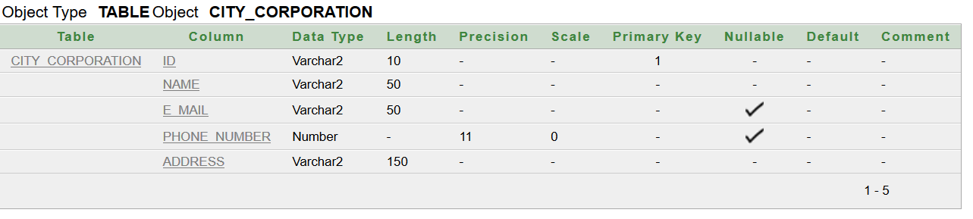

* CREATE TABLE Graveyard ( GrvYrd_ID VARCHAR2(15) PRIMARY KEY, GrvYrd_Name VARCHAR2(50) NOT NULL, GrvYrd_Area VARCHAR2(15) NOT NULL, GrvYrd_Address VARCHAR2(150) NOT NULL, ID VARCHAR2(10), FOREIGN KEY (ID) REFERENCES City_Corporation (ID) );

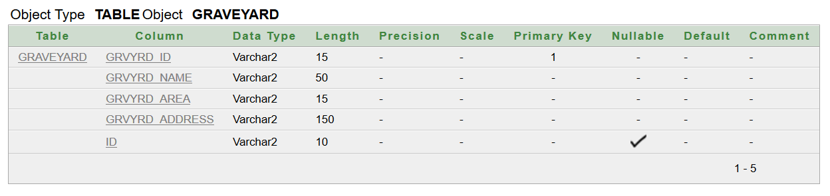

* CREATE TABLE Manager( M_ID VARCHAR2(15) PRIMARY KEY, M_Name VARCHAR2(50) NOT NULL, NID VARCHAR2(16) UNIQUE, Address VARCHAR2(150) NOT NULL, E_mail VARCHAR2(50) UNIQUE, Phone_Number VARCHAR2(11) UNIQUE, Gender VARCHAR2(6) NOT NULL, CHECK (Gender='Male' or Gender='Female'), Blood_Group VARCHAR2(6) NOT NULL, CHECK (Blood_Group='A+ve' or Blood_Group='A-ve' or Blood_Group='B+ve' or Blood_Group='B-ve' or Blood_Group='AB+ve' or Blood_Group='AB-ve' or Blood_Group='O+ve' or Blood_Group='O-ve'), Date_of_Birth VARCHAR2(10) NOT NULL, Hiredate DATE NOT NULL, Salary VARCHAR2(6) NOT NULL, GrvYrd_ID VARCHAR2(10), FOREIGN KEY (GrvYrd_ID) REFERENCES Graveyard (GrvYrd_ID) );

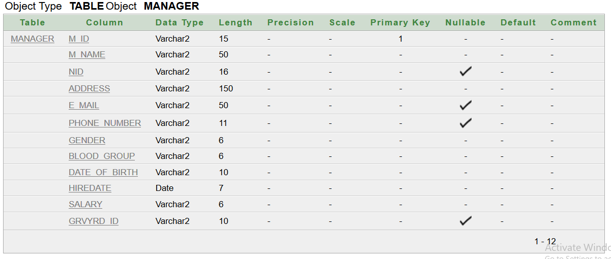

* CREATE TABLE Dept( Dept_ID VARCHAR2(10) PRIMARY KEY, Dept_Name VARCHAR2(50) NOT NULL );

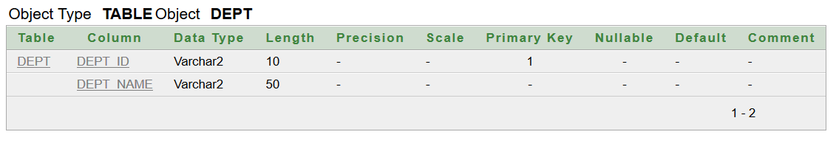

* CREATE TABLE Emp( Emp_No VARCHAR2(10) PRIMARY KEY, Emp_Name VARCHAR2(50) NOT NULL, NID VARCHAR2(16) UNIQUE, Address VARCHAR2(150) NOT NULL, E_mail VARCHAR2(50), Phone_Number NUMBER(13) UNIQUE, Blood_Group VARCHAR2(6) NOT NULL, CHECK (Blood_Group='A+ve' or Blood_Group='A-ve' or Blood_Group='B+ve' or Blood_Group='B-ve' or Blood_Group='AB+ve' or Blood_Group='AB-ve' or Blood_Group='O+ve' or Blood_Group='O-ve'), Date_of_Birth DATE NOT NULL, Hiredate DATE NOT NULL, Salary VARCHAR2(6) NOT NULL, Gender VARCHAR2(6) NOT NULL, CHECK (Gender='Male' or Gender='Female'), Dept_ID VARCHAR2(10) NOT NULL, M_ID VARCHAR2(15) NOT NULL, FOREIGN KEY (Dept_ID) REFERENCES Dept (Dept_ID), FOREIGN KEY (M_ID) REFERENCES Manager (M_ID) );

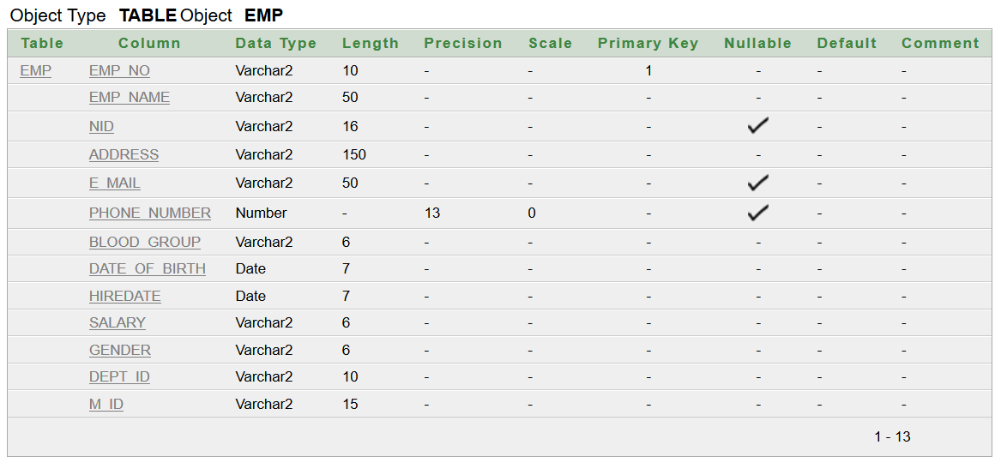

* CREATE TABLE Zone_Officer( O_ID VARCHAR2(15) PRIMARY KEY, O_Name VARCHAR2(50) NOT NULL, O_Address VARCHAR2(150) NOT NULL, O_Phone_Number VARCHAR2(11) UNIQUE, O_E_mail VARCHAR2(50) UNIQUE, NID VARCHAR2(16) UNIQUE, Gender VARCHAR2(6) NOT NULL, CHECK (Gender='Male' or Gender='Female'), M_ID VARCHAR2(15), ID VARCHAR2(10), FOREIGN KEY (M_ID) REFERENCES Manager (M_ID), FOREIGN KEY (ID) REFERENCES City_Corporation (ID) );

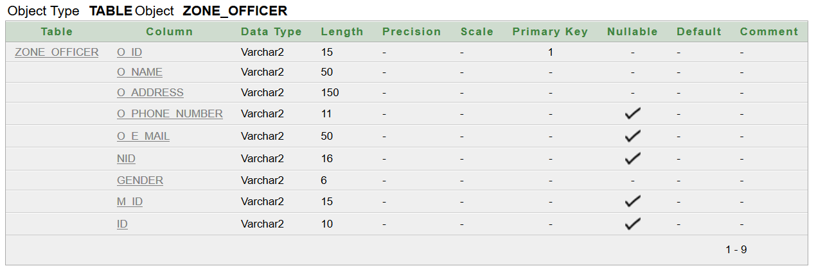

* CREATE TABLE Corps ( C_ID VARCHAR2(15) PRIMARY KEY, C_Name VARCHAR2(50) NOT NULL, NID VARCHAR2(16) UNIQUE, Death_Certificate_No VARCHAR2(20) UNIQUE, C_Address VARCHAR2(150) NOT NULL, Date_of_Birth DATE NOT NULL, Date_of_Death DATE NOT NULL, Reason_of_Death VARCHAR2(50), Gender VARCHAR2(6), CHECK (Gender='Male' or Gender='Female'), M_ID VARCHAR2(15), FOREIGN KEY (M_ID) REFERENCES Manager (M_ID) );

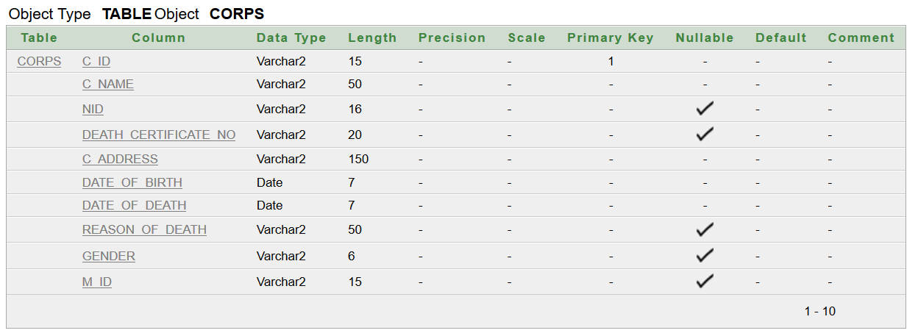

* CREATE TABLE Relative( R_Name VARCHAR2(50) NOT NULL, R_Address VARCHAR2(150) NOT NULL, R_Phone_No VARCHAR2(11) UNIQUE, C_ID VARCHAR2 (15), M_ID VARCHAR2(15), FOREIGN KEY (C_ID) REFERENCES Corps (C_ID), FOREIGN KEY (M_ID) REFERENCES Manager (M_ID), CONSTRAINT PK_123 PRIMARY KEY (C_ID, R_Name, M_ID) );

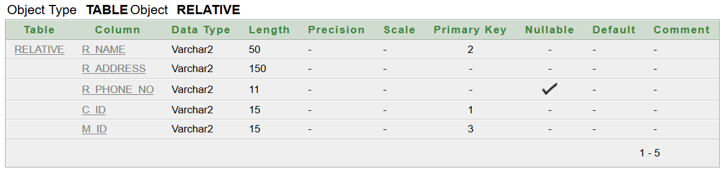

* CREATE TABLE Loc ( Loc_ID VARCHAR2(10) PRIMARY KEY, Block VARCHAR2(5) NOT NULL, Plot VARCHAR2(5) NOT NULL );

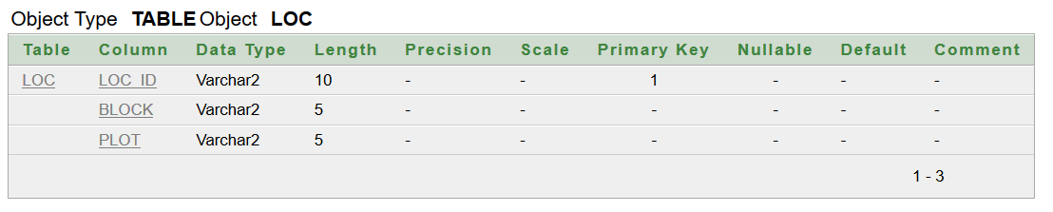

* CREATE TABLE Grave_Size( Grave_Size_ID VARCHAR2(15) PRIMARY KEY, Adult VARCHAR2(5), Young VARCHAR2(5), Child VARCHAR2(5) );

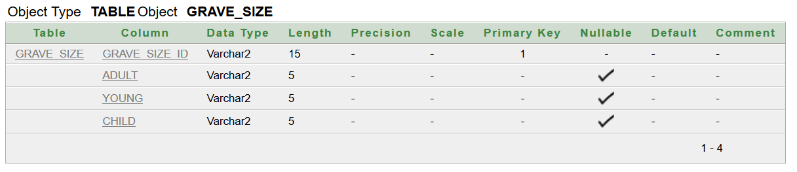

* CREATE TABLE Grave ( Grave_ID VARCHAR2(15) PRIMARY KEY, Loc_ID VARCHAR2(10), Grave_Size_ID VARCHAR2(15), GrvYrd_ID VARCHAR2(15), C_ID VARCHAR2(15), FOREIGN KEY (Loc_ID) REFERENCES Loc (Loc_ID), FOREIGN KEY (C_ID) REFERENCES Corps (C_ID), FOREIGN KEY (GrvYrd_ID) REFERENCES Graveyard (GrvYrd_ID) );

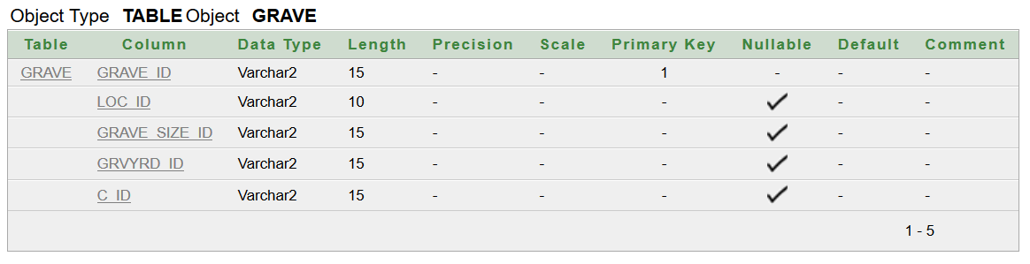

**DATA INSERTION**

**City_Corporation**

INSERT INTO City_Corporation VALUES ('1000','Dhaka South City Corporation','mayor@dhakasouthcity.gov.bd','9563506','Nagar Bhaban, Dhaka South City Corporation, Fulbaria, Dhaka-1000.');

**GRAVEYARD**

INSERT INTO Graveyard VALUES('GY-1000-1','Azimpur Graveyard', '32 Acres', 'Area-3, Ward -62, Lalbagh-Azimpur Road, Dhaka.','1000');

**Dept**

INSERT INTO Dept VALUES ('GYD-1200-1','Gravedigger');

INSERT INTO Dept VALUES ('GYD-1200-2','Security');

INSERT INTO Dept VALUES ('GYD-1200-3','Cleaner');

INSERT INTO Dept VALUES ('GYD-1200-4','Washer');

INSERT INTO Dept VALUES ('GYD-1200-5','Gardener');

**Manager**

INSERT INTO Manager VALUES('GYM-1000-82','Md. Alamgir', '1961802270157098', 'Nilkhet', 'malamgir61@gmail.com', '01710000001', 'Male','AB+ve', '19-03-1961', '17-Nov-1981', '15000', 'GY-1000-1');

**Emp**

INSERT INTO Emp VALUES('GYE-1000-2','Samsul Haque', '1961802270394090', 'Nilkhet', 'NULL', '01710000002','B+ve', '03-May-1961', '30-Nov-1981', '9000','Male', 'GYD-1200-3','GYM-1000-82');

INSERT INTO Emp VALUES('GYE-1000-3','Noor Mohammad Sheikh', '1963805270157090', 'Science Lab', 'NULL', '01710000003','O-ve', '28-Jul-1963', '30-Nov-1981', '9500','Male', 'GYD-1200-1','GYM-1000-82');

INSERT INTO Emp VALUES('GYE-1000-4','Bodrul Mia', '1967802270157490', 'Nilkhet', 'NULL', '01710000004','AB+ve', '01-Nov-1967', '30-Nov-1981', '1000','Male', 'GYD-1200-4','GYM-1000-82');

INSERT INTO Emp VALUES('GYE-1000-5','Aleya Begum', '1959802279137050', 'Azimpur', 'NULL', '01710000005','O+ve', '12-Dec-1959', '01-Jan-1990', '8000','Female', 'GYD-1200-2','GYM-1000-82');

INSERT INTO Emp VALUES('GYE-1000-6','Amena Anjum', '1960872270157040', 'Jigatola', 'NULL', '01710000006','O+ve', '28-Feb-1960', '30-Nov-1981', '7000','Female', 'GYD-1200-5','GYM-1000-82');

INSERT INTO Emp VALUES('GYE-1000-7','Kamruddin Alam', '1966807270157050', 'Nilkhet', 'NULL', '01710000007','AB-ve', '15-Nov-1963', '30-Nov-1981', '8000','Male', 'GYD-1200-2','GYM-1000-82');

INSERT INTO Emp VALUES('GYE-1000-8','Samad Khan', '1961830270157020', 'Lalbag', 'NULL', '01710000008','B+ve', '18-Feb-1961', '21-Jan-1988', '9000','Male', 'GYD-1200-3','GYM-1000-82');

INSERT INTO Emp VALUES('GYE-1000-9','Boishakhi Khanom', '1960802270157530', 'Bosila', 'NULL', '01710000009','AB+ve', '09-Jul-1960', '07-Aug-1985', '9500','Female', 'GYD-1200-1','GYM-1000-82');

INSERT INTO Emp VALUES('GYE-1001-0','Md. Touhid', '1964802270157090', 'Nilkhet', 'NULL', '01710000010','B-ve', '03-Dec-1964', '07-Feb-1984', '8000','Male', 'GYD-1200-2','GYM-1000-82');

**Loc**

INSERT INTO Loc VALUES('L-701','G','57');

INSERT INTO Loc VALUES('L-702','G','58');

INSERT INTO Loc VALUES('L-592','E','78');

INSERT INTO Loc VALUES('L-345','C','30');

INSERT INTO Loc VALUES('L-1176','K','45');

INSERT INTO Loc VALUES('L-112', 'A', '3');

INSERT INTO Loc VALUES('L-222', 'D', '8');

INSERT INTO Loc VALUES('L-001', 'A', '1');

INSERT INTO Loc VALUES('L-021', 'A', '76');

**Corps**

INSERT INTO Corps VALUES ('GYC-1000-01','Abdul Sattar','NULL','2017573956329501','Bongshal','15-Jan-2017','11-Aug-2017', 'Accident','Male','GYM-1000-82');

INSERT INTO Corps VALUES ('GYC-1000-02','Milon Khan', '1964802270157090', '2006433356329500 ','Farmgate','18-Aug-1964','30-Sep-2006', 'Heart Attack','Male','GYM-1000-82');

INSERT INTO Corps VALUES ('GYC-1000-03','Rahima Khatun', '1997802270157090', '2000573957629520','Panthapath','19-May-1997','15-Mar-2000', 'Suicide','Female','GYM-1000-82');

INSERT INTO Corps VALUES ('GYC-1000-04','Md. Bijoy','1947803370557090','2011973257869520','Azimpur','14-May-1947','11-Nov-2011', 'Murdered','Male','GYM-1000-82');

INSERT INTO Corps VALUES ('GYC-1000-05','Anika Parvin',' 201802290350832', '2018583367612520','Bonosree','05-Dec-2008','08-Jun-2018', 'Murdered','Female','GYM-1000-82');

INSERT INTO Corps VALUES ('GYC-1000-06','Antora Shikdar','2009458290350148','2009973157629520','Bonosree','29-Sep-1999','07-Aug-2009', 'Accident','Female','GYM-1000-82');

INSERT INTO Corps VALUES ('GYC-1000-07','Nandini Chowdhury','1999936490350932','1985573987619530','Kathalbagan','21-Mar-1985','12-Mar-1999', 'Accident','Female','GYM-1000-82');

INSERT INTO Corps VALUES ('GYC-1000-08','Kamrul Hasan','2009802290350830','2018273927659650','Chankharpul','17-May-1905','02-Jan-2018', 'Stroke','Male','GYM-1000-82');

INSERT INTO Corps VALUES ('GYC-1000-09','Abu Bakkar','1984802271057090','2010273957622320','Azimpur','05-Feb-1984','21-Sep-2010', 'Suicide','Male','GYM-1000-82');

**Relative**

INSERT INTO Relative VALUES ('Abdul Jabbar','Bongshal','01835498210','GYC-1000-01','GYM-1000-82');

INSERT INTO Relative VALUES ('Hasan Molla','Farmgate','01792540164','GYC-1000-02','GYM-1000-82');

INSERT INTO Relative VALUES ('Jolil Ali','Panthapath','01912486593','GYC-1000-03','GYM-1000-82');

INSERT INTO Relative VALUES ('Abdul Kader','Azimpur','01693629721','GYC-1000-04','GYM-1000-82');

INSERT INTO Relative VALUES ('Abul Hasan','Bonosree','01793105310','GYC-1000-05','GYM-1000-82');

INSERT INTO Relative VALUES ('Jamal Uddin','Bonosree','01756297430','GYC-1000-06','GYM-1000-82');

INSERT INTO Relative VALUES ('Sabbir Hasan','Kathalbagan','01682385321','GYC-1000-07','GYM-1000-82');

**Grave_Size**

INSERT INTO Grave_Size VALUES ('GS-1000-01','NULL','NULL','50×10');

INSERT INTO Grave_Size VALUES ('GS-1000-02',' 75×30','NULL','NULL');

INSERT INTO Grave_Size VALUES ('GS-1000-03','NULL',' 65×20','NULL');

INSERT INTO Grave_Size VALUES ('GS-1000-04',' 75×30','NULL','NULL');

INSERT INTO Grave_Size VALUES ('GS-1000-05','NULL','NULL','50×10');

INSERT INTO Grave_Size VALUES ('GS-1000-06','NULL','NULL','50×10');

INSERT INTO Grave_Size VALUES ('GS-1000-07','NULL',' 65×20','NULL');

INSERT INTO Grave_Size VALUES ('GS-1000-08',' 75×30','NULL','NULL');

INSERT INTO Grave_Size VALUES ('GS-1000-09',' NULL','65×20','NULL');

**Grave**

INSERT INTO Grave VALUES ('GYG-1000-01','L-701','GS-1000-01','GY-1000-1','GYC-1000-01');

INSERT INTO Grave VALUES ('GYG-1000-02','L-702','GS-1000-02','GY-1000-1','GYC-1000-02');

INSERT INTO Grave VALUES ('GYG-1000-03','L-592','GS-1000-03','GY-1000-1','GYC-1000-03');

INSERT INTO Grave VALUES ('GYG-1000-04','L-345','GS-1000-04','GY-1000-1','GYC-1000-04');

INSERT INTO Grave VALUES ('GYG-1000-05','L-1176','GS-1000-05','GY-1000-1','GYC-1000-05');

INSERT INTO Grave VALUES ('GYG-1000-06','L-112','GS-1000-06','GY-1000-1','GYC-1000-06');

INSERT INTO Grave VALUES ('GYG-1000-07','L-222','GS-1000-07','GY-1000-1','GYC-1000-07');

INSERT INTO Grave VALUES ('GYG-1000-08','L-001','GS-1000-08','GY-1000-1','GYC-1000-08');

INSERT INTO Grave VALUES ('GYG-1000-09','L-021','GS-1000-09','GY-1000-1','GYC-1000-09');

**Zone Officer**

INSERT INTO Zone_Officer VALUES ('ZO-1000-7','Mohammad Nazmul Islam','Wari','9563507', 'zoneofficer07@dhakasouthcity.gov.bd','1966729461052963','Male','GYM-1000-82','1000');

**QUERY WRITING**

**CONCLUTION:**

After finishing this project, we can say that our project can be helpful for the management of the graveyard. But, we also have to say that it’s not totally complete. There can be mistakes and still scope for advancement. After advancement this will be better, efficient, user friendly. Here we use only oracle software, if we want to really make it usable we have to add it with a software. Then we can use the user interface and other things. With that, it will be truly ready to use.

**THE END**